**Aim:** Implementation of Paging Technique of Memory Management

# Program:

#include<stdio.h> #include<unistd.h> void main()

{

int i,ms,fs,fa,p,ps,reqp,pss,pno,pageno,o,pa,y; int a[100][100];

do{

printf("enter memory size:"); scanf("%d",&ms); printf("enter frame size:"); scanf("%d",&fs);

fa=ms/fs;

printf("no. of frames available %d\n",fa); printf("enter no.of prosess:"); scanf("%d",&p);

for(int k=0;k<p;k++)

{

printf("enter process %d size",k,":"); scanf("%d",&ps);

reqp=ps/fa;

printf("no.of frames required by process %d",k); printf(":%d\n",reqp);

printf("enter frames for process:"); for(i=0;i<reqp;i++){ scanf("%d",&a[k][i]);

} }

printf("enter logical address:process no:"); scanf("%d",&pno);

printf("page no.:"); scanf("%d",&pageno); printf("offset:");

scanf("%d",&o); pa=(fs*a[pno][pageno])+o; printf("physical address:%d",pa); printf("Do you want to continue : (1/0) " ); scanf("%d",&y);

}while(y==1);

}

# Output:

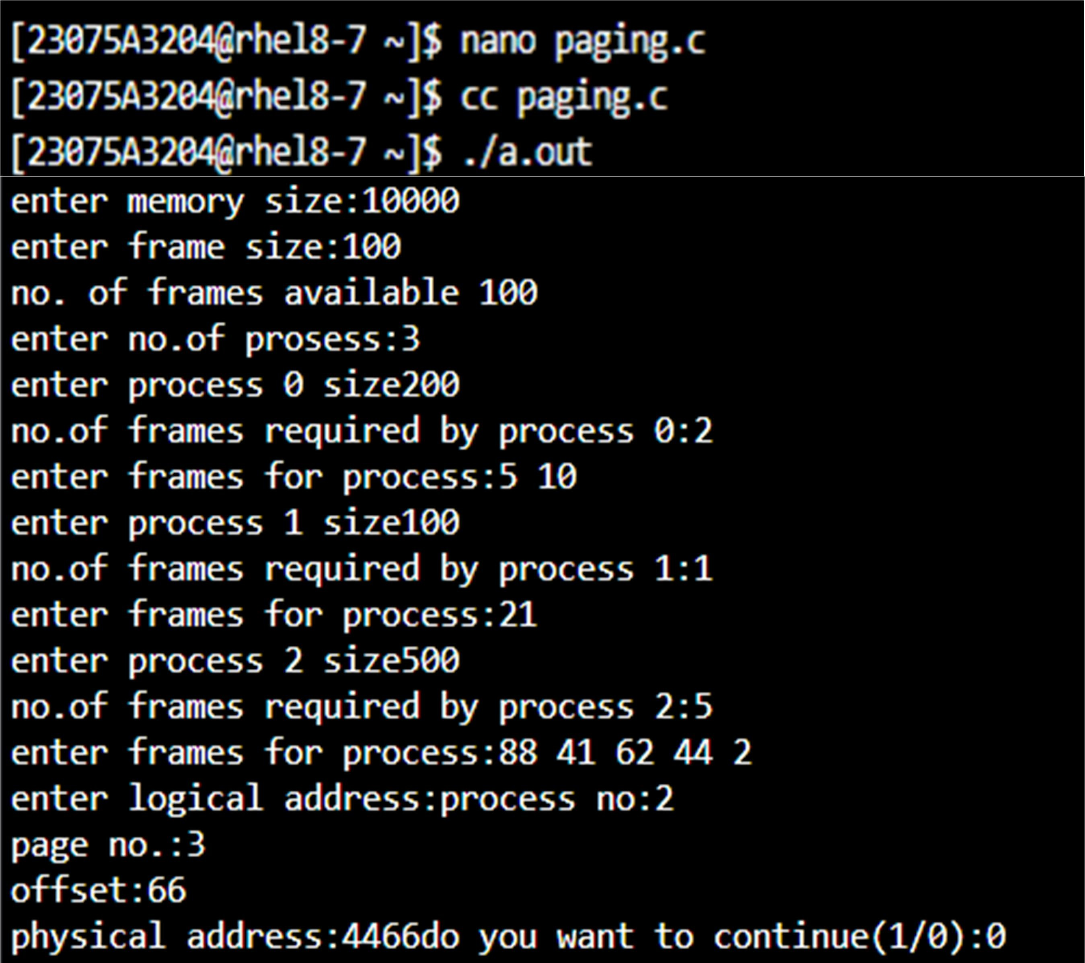

**Aim:** Simulate frame allocation methods a.minimum number of frames

b.equal allocation c.proportional allocation **Program:** #include<stdio.h> #include<unistd.h>

void min(int ms,int fs){ int p[100],n,min,s=0;

printf("enter no of process:"); scanf("%d",&n);

for(int i=0;i<n;i++){ printf("enter process %d size:",i); scanf("%d",&p[i]);

printf("req frame for process: %d\n",p[i]/fs);

}

printf("enter min.no.of frames:"); scanf("%d",&min); printf("process\tpsize\treq\tallocate\n"); for(int i=0;i<n;i++){

printf("%d\t%d\t%d\t%d\n",i,p[i],(p[i]/fs),min); s=s+min;

}

printf("leftover %d",(ms/fs)-s);

void eql(int ms,int fs){ int p[100],n,s=0;

printf("enter no of process"); scanf("%d",&n);

for(int i=0;i<n;i++){ printf("enter process %d size:",i); scanf("%d",&p[i]);

printf("req frame for process%d\n",p[i]/fs);

}

int e=(ms/fs)/n; printf("process\tpsize\treq\tallocate\n"); for(int i=0;i<n;i++){

s=s+e; printf("%d\t%d\t%d\t%d\n",i,p[i],(p[i]/fs),e);

}

printf("leftover frames:%d",(ms/fs)-s);

}

void prop(int ms,int fs){ int n,p[100],s=0,se=0,x;

printf("enter no of process:"); scanf("%d",&n);

for(int i=0;i<n;i++){

printf("enter procees %d size:",i); scanf("%d",&p[i]);

s+=p[i];

printf("req frames for process%d\n",p[i]/fs);

printf("process\tpsize\treq\tallocate\n"); for(int i=0;i<n;i++){ x=(p[i]*(ms/fs))/s;

printf("%d\t%d\t%d\t%d\n",i,p[i],p[i]/fs,x); se+=x;

}

printf("leftover frames:%d",(ms/fs)-se);

}

void main(){ int ms,fs,nf,x;

printf("enter memory size:"); scanf("%d",&ms); printf("enter frame size:"); scanf("%d",&fs);

nf=ms/fs;

printf("no of frames: %d",nf); int y=1;

while(y==1){

printf("\nselect 1:minimum 2:equal 3:proportional"); scanf("%d",&x);

switch(x){

case 1:min(ms,fs); break;

case 2:eql(ms,fs); break;

case 3:prop(ms,fs); break;

}

printf("enter 1/0 to cnt"); scanf("%d",&y);

}

}

# Output:

